EMAC – ISPF Edit Command Selection Dialog

*By Lionel B. Dyck*

# Overview

EMAC is an ISPF Edit Macro (command) that is available under both ISPF Edit and View. It presents the user with a list of available ISPF Edit Macros that are available for use. The presentation is an ISPF Table that supports several commands as well as two selection options. An ISPF Tutorial is provided for the user to assist with the use of this dialog.

The Primary commands that are supported are:

**Find** Will find a string in either the Macro name or the Description and position  
 the table to that row. Repeat find is supported.

e.g. Find help

**Locate** Will locate the Macro that matches, or begins, with the provided string.

e.g. Locate D

**Only** Will limit the display of macros to those that include the provided string.

e.g. Only add

**Refresh** Will Rebuild the table of macros will all macros. For use after using Only.

e.g. Refresh

macro Will find the macro name provided and select it for execution.

e.g. $do

Abbreviations for these commands is the 1st character of the comment. F for Find, O for Only, etc.

Macro selection options are:

**S** Select the macro to execute

**H** Display any ISPF Tutorial or TSO Help information for the macro

Some Edit macros require either a cursor position or row selection(s) to operate. These must be entered prior to invoking the EMAC command. Any require, or optional, macro parameters will be solicited via a prompting panel after macro selection.

Below is a sample of the Edit Macro selection table:

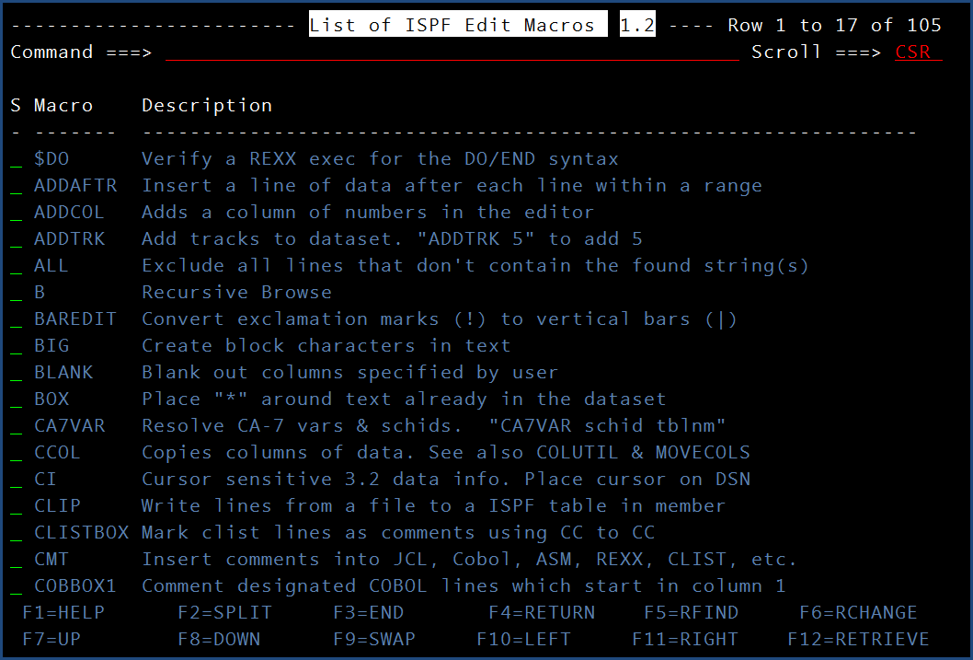

After selecting a macro to execute the following panel will be displayed to allow the user to enter any required, or optional, parameters for the macro:

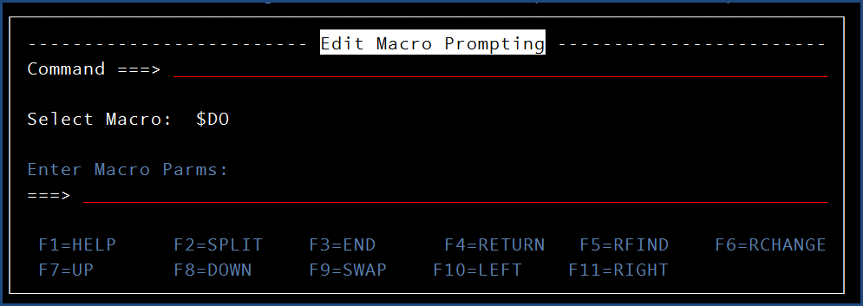

If EMAC is entered outside of ISPF Edit or View the following ISPF Tutorial panel will be displayed to inform the user of their error:

